**DATABASE Design**

1. **Customer**

|  |
| --- |
| Customer |
| Customer-ID  Name  Email  Gender  Age  Password |

1. **Product**

|  |
| --- |
| Product |
| Product-ID  Category  Product Name  Price |

|  |
| --- |
| Order |
| Order-ID  Cust-ID  Product-ID  Contact-Number  Delivery-Address  Order-Status |

1. **Orders**

1. **Offers**

|  |
| --- |
| Offer |
| ID  Name  Duration  Description |

1. **Queries**

|  |
| --- |
| Query |
| Query-ID  Customer-ID  Product-ID  created-Date  Description |

**Architecture diagram**

**EasyKart**

**Resgistration**

**Login**

**Logout**

**Login**

**View Products**

**Admin**

**Help**

**Cart**

**Login**

**Update**

**Delete**

**Add**

**Logout**

**Select category**

**Browse Products**

**View Product Details**

**ge**

**Contact us**

**Add to cart**

**Remove from cart**

**Checkout**

**Payment**

**UM**

**UML Diagram**

1. **Class Diagram**

**Order**

**Customer**

**1 \***

**Cust_id:integer**

**Name:string**

**Id:integer**

**Product_name:string**

**Amount:double**

**Select_product()**

**Payment()**

**Acknowledge()**

**Confirm()**

**Product**

**Admin**

**Id:integer**

**Product_name:string**

**Category:string**

**Amount:double**

**Admin login()**

**1 \***

**add_product()**

**remove_product()**

**update_product()**

**Confirm()**

1. **FLOW CHART FOR USER LOGIN/REGISTRATION PAGE:**

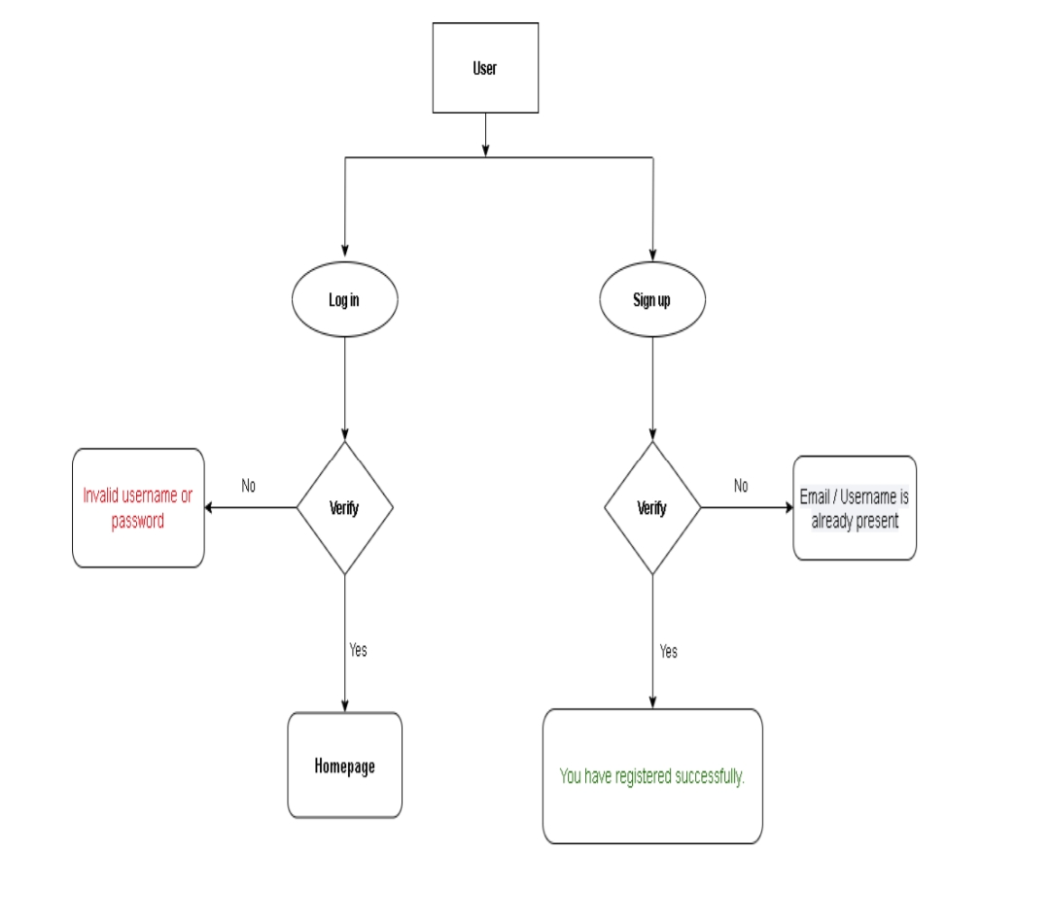

1. **FLOW CHART FOR ADMIN:**

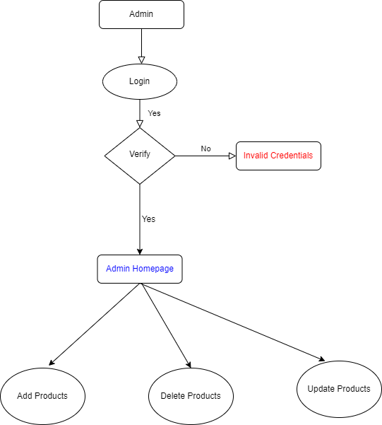

1. **Use-case Diagram**

Authentication

Login

view product

<<include>>

Payment gateway

Place order

**customer**

Query

Admin

Update plans

Customer support